A-O-1

INFLUENCE OF AEROSOL LOADING ON SEA SURFACE TEMPERATURE (SST) VARIATIONS – A CASE STUDY

Shailesh Kumar Kharol, K.V.S. Badarinath and P.K.Dileep

Atmospheric Science Section, Oceanography Division, National Remote Sensing Agency (Dept. of Space-Govt. of India) Balanagar, Hyderabad – 500 037, India.

*Corresponding Author. Email: badrinath_kvs@nrsa.gov.in

INTRODUCTION
The sea surface temperature (SST) that can be derived from satellite observations is one of the important parameters for understanding the global climate system. The variability of sea surface temperatures has a significant socio-economic impact over the tropics and subtropics and is also one of the dominant factors in understanding the global and regional climate changes. Oceanographers and climatologists make extensive use of SSTs estimated from thermal remote sensing data collected by space borne sensors. Users' requirements for the accuracy of SST has been more demanding, and as a result, the differing bias characteristics of various SST products are subject to greater scrutiny (Diaz et al., 2001). Atmospheric aerosols from volcanic particles, dust, smoke, etc. in higher concentrations can introduce such large biases (>1.0 ⁰C) in satellite derived SST retrievals by significantly increasing infrared signal attenuation and scattering. The influence of volcanic aerosols in decreasing AVHRR derived SSTs was evident during most of 1982-1983 and in 1991-1992 El Chichon and Mount Pinatubo volcanic eruptions respectively (Strong et al., 2000). Dust plumes from North Africa are the most prominent and persistent aerosols covering the largest ocean areas (Husar et al., 1997; Prospero, 1999) that effect the SST derivation. Saharan dust in the atmosphere modified up-welling radiation over a broad range of thermal wavelengths that includes the “windows” used for remote sensing of SST (e.g., Deschamps & Phulpin, 1980). Since dust aerosols are prominent during summer and pre-monsoon periods in India it is worthwhile to investigate the influence of dust aerosols on satellite-derived SST retrievals.

DATASETS AND METHODOLOGY
The sea surface temperature derived from TRMM Microwave Imager (TMI) onboard the Tropical Rainfall Measuring Mission (TRMM) satellite for the period April 2006 was used in the study. TMI radiometer is well-calibrated and contains lower frequency channels required for sea surface temperature retrievals. The entire data set includes sea surface temperatures (SST), surface wind speeds derived using two different radiometer channels (11 and 37 GHz), atmospheric water vapor, liquid cloud water and rain rates. The aerosol Index (AI) value observed from the TOMS instrument continued by the Ozone Monitoring Instrument (OMI) flown on the EOS Aura spacecraft launched in July 2004 (Levelt, et al., 2000, Ahmad et al., 2003). The absorbing AI from TOMS is defined as the difference between the measured spectral contrast at the 360 and 331 nm wavelength radiances and the contrast calculated from the radiative transfer theory for a pure molecular (Raleigh particles) atmosphere.
AI is mathematically defined as:

AI= -100[log₁₀(I ₃₆₀/ I ₃₃₁)_{meas} – log10(I ₃₆₀ / I ₃₃₁)_{calc}] (1)
Since Ι₃₆₀ calculation uses reflectivity derived from the I₃₃₁ measurements, the AI definition essentially simplifies to:

AI= 100 log₁₀ (Ι_{360_meas}/Ι_{360_calc}) (2)

RESULTS AND DISSCUSSION
In the present study, comparison with independent satellite measurements of Aerosol Index (AI) and sea surface temperature (SST) have been done over Bay of Bengal region during April, 2006, corresponding to summer season over Indian subcontinent. A number of dust storm events occurred during the period as observed in data from different satellite sensors (e.g. OMI, MODIS and AVHRR) over the region. Dust is a mineral tropospheric aerosol intermittently lofted from the desert in air streams and transport over the ocean. Dust storms are associated with a decrease in radiance and associated brightness temperature as dust aerosols scatter EMR in visible and near IR wavelengths and absorb thermal IR wavelengths. This radiance decrease represents the radiative forcing of dust. Figure – 1(a) shows the TOMS-OMI Aerosol Index over the Indian region and, figure – (1b) shows the monthly average TMI-SST over Bay of Bengal region, during April, 2006. It is clear from the figure -1 (a & b) that Bay of Bengal region influenced by higher aerosol loading due to predominantly dust aerosols resulting in reduced solar radiation reaching the ocean surface and corresponding decrease in TMI-SST In order to estimate the effect of aerosols on satellite-derived SST, correlation studies between SST and Aerosol Index (AI) were carried out at different locations in Bay of Bengal region for the month of April, 2006. Scatterplot of SST and AI for the location 86.75 E longitude, 17.5 N latitude is shown in figure–2. The negative correlation (R² = 0.76) of SST with aerosol index suggested reduction in solar flux at the sea surface due to the absorption/scattering of short wave radiation by the dust aerosols. The slope of the graph suggests that a unit increase in aerosol index reduces the sea surface temperature by 1.2 ⁰C.

CONCLUSIONS
In the present study, influence of dust aerosols on SST retrieved from satellite-based sensors were carried out from two independent satellite sensors, TOMS-OMI and TRMM Results of the study suggested that –
- Dust aerosols transported from desert regions during summer period affect Bay of Bengal region.
- Aerosols, predominantly from dust storms can have a significant effect on SST variations.

Acknowledgements
The authors thank Director, NRSA and Dy.Director (RS&GIS-AA) for necessary help at various stages and ISRO-GBP for funding support.

REFERENCES
- Ahmad, S. P., P. F. Levelt, P. K. Bhartia, E. Hilsenrath, G.W. Leppelmeier, and J. E. Johnson, (2003), Atmospheric Products from the Ozone Monitoring Instrument (OMI), Proceedings of SPIE conference on Earth Observing Systems VIII, Volume 5151, pp 619630. (http://acdisc.gsfc.nasa.gov/ozone/docs/omispie 2003. doc)
- Deschamps, P. Y., and Phulpin, T., (1980). Atmospheric correction of infrared measurements of sea surface temperature using channels at 3.7, 11 and 12 μm. Boundary-Layer Meteorology, 18, 131−143.
- Husar, R.B., J. M.Prospero, and L. L. Stowe, (1997), Characterization of tropospheric aerosols over the oceans with the NOAA advanced very high resolution radiometer optical thickness operational product, J. Geophys. Res., 102, 16889-16909.
- Levelt, P. F et al., (2000), Science Objectives of EOSAura's Ozone Monitoring Instrument (OMI), Proc. Quad. Ozone Symposium, Sapporo, Japan, pp. 127128.
- Prospero, J. M., (1999), Long-term measurements of the transport of African mineral dust to the Southeastern United States: Implications for regional air quality, J. Geophys. Res., 104, 15917- 15927.
- Strong, A.E., E.J. Kearns, and K.K. Gjovig, (2000), Sea surface temperature signals from satellites - An update. Geophys. Res. Lett., 27, 1667-1670.
- Diaz, J. P., Arbelo, M., Exp_osito F. J., Podest G. , Prospero J. M.and. Evans R (2001), “Relationship between errors in AVHRR-derived sea surface emperature and the TOMS Aerosol Index”, Geophys. Res. Lett, 28, 1989-1992.

(a) (b)
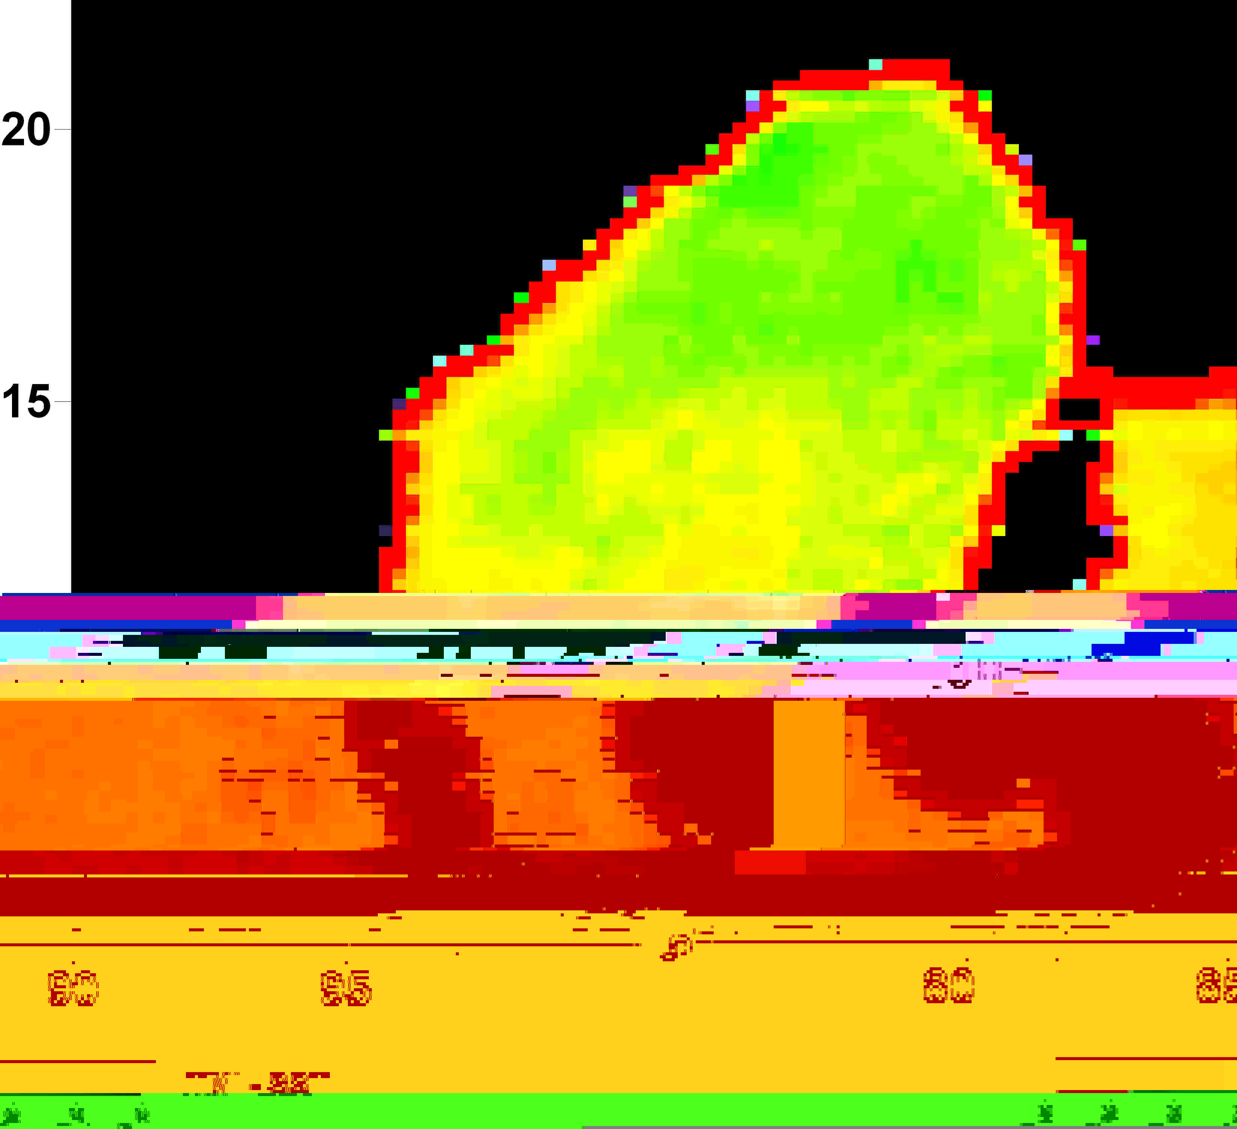
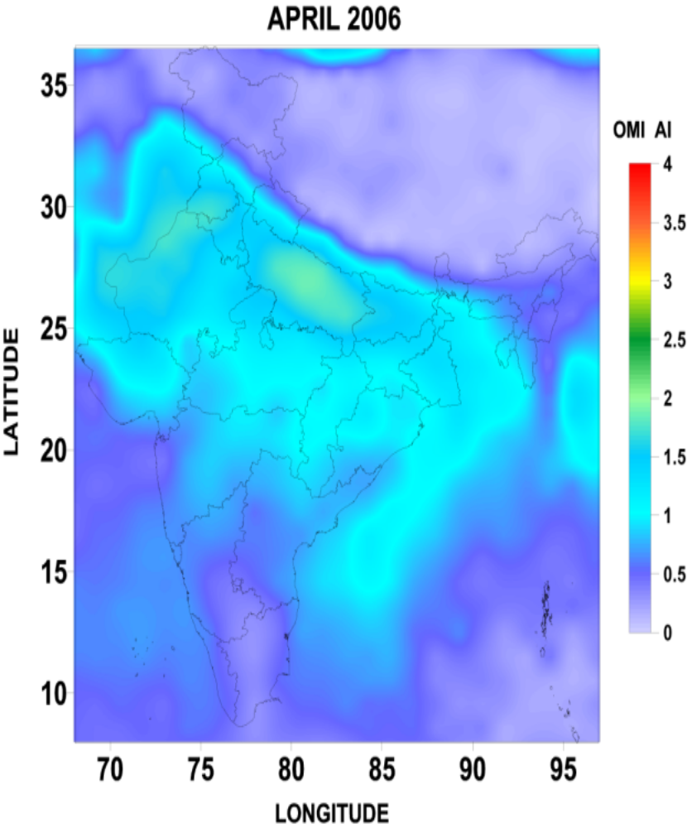

Figure – 1 a) Sea surface temperature for April 2006 from TRMM Microwave Imager and b) TOMS-OMI Aerosol Index over Bay of Bengal Region

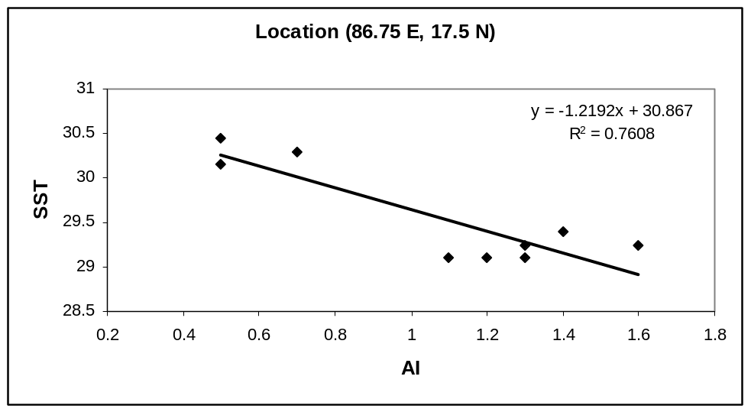

Figure – 2 Scatter plot of Sea Surface temperature (SST) and Aerosol Index (AI) during April, 2006.

